Open and Closed Manometer Problems

Pgas = Patm Pgas > Patm Pgas < Patm
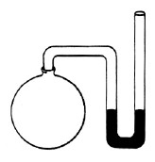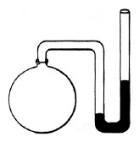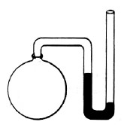
A

B

h

C

h

Pgas = Patm + h Pgas = Patm - h

- An open manometer is filled with mercury. The mercury level is 12mm higher on the side open to the atmosphere. What is the total pressure of the gas, in kPa, if the atmospheric pressure is 100.8 kPa?

- An open manometer is filled with mercury and connected to a container of hydrogen gas. The mercury level is 57mm higher in the arm of the tube connected to the hydrogen. If the atmospheric pressure is 0.985 atm, what is the pressure of the hydrogen gas, in atmospheres?

- A closed manometer is filled with mercury and attached to a container of helium. The difference in height of mercury between the two arms is 521 mm. What is the pressure of the helium, in torr?

- An open manometer connected to a tank of argon has a mercury level 83 mm higher in the atmospheric arm. If the atmospheric pressure is 76.9 kPa, what is the pressure of the argon in kPa?

- A closed manometer is filled with mercury and attached to a container of nitrogen gas. The difference in height of mercury in the two arms is 435 mm. What is the pressure of the nitrogen gas in kPa, atm, and torr?

- The mercury level in the sample arm of an open manometer is 546mm higher than in the open arm when the atmospheric pressure is 88.9 kPa. What is the pressure of the gas?

- An open manometer is filled with mercury and the closed end is filled with ammonia. If the mercury rises 23.4mm on the side of the manometer attached to the ammonia, what is the pressure of the ammonia if the atmospheric pressure is 716 torr?

- A closed manometer is filled with mercury and attached to a container of oxygen gas. The difference in height of mercury in the two arms is 37 mm. What is the pressure of the oxygen gas in torr, atm and kPa?

- An open manometer is filled with mercury and connected to a container of chlorine gas. The mercury level is 120.1 mm higher in the arm of the tub open to the atmosphere. Atmospheric pressure is 99.8 kPa. What is the pressure of the chlorine gas, in kPa?

