Introduction to Matter
Part 2: Physical Properties and Phase Change
1. What is brittleness?

2. Give an example of a brittle material. _____________________
3. What is malleability?

4. Give an example of a malleable material. _______________________
5. In general, most ____________________ are malleable and ____________________are not.
6. Add brittleness and malleability to your list of physical properties.
7. Definition of physical change –

8. What are the melting point and boiling points of water in degrees Celsius?
Melting point __________________ Boiling point __________________
9. Is freezing water a physical change or a chemical change? _______________________ Explain your answer.

10. What is a phase change?

11. Is boiling water a physical change or a chemical change? ______________________
Explain your answer.

12. Phase changes are _________________________ (physical or chemical) changes.
13. Phase changes often occur in response to changes in __________________.
14. As the temperature of a system increases, the ENTHALPY of the system also increases. What is enthalpy?

15. As heat is added to a solid system, the enthalpy of the system increases and the molecules begin to vibrate faster and faster. Eventually the attractive forces between the molecules or atoms will begin to break and the solid will _____________________. If more heat is added the molecules will vibrate even more and the liquid will vaporize.
16. Vaporization

____________________ _____________________

Takes place at the surface of a Takes place all throughout the body
liquid and at any temperature. of a liquid and at only one temperature.

17. Phase changes
Solid → Liquid
Liquid → Solid
Liquid → Gas
Gas → Liquid
Solid →Gas
Gas→Solid

18. What is the definition of freezing point?

19. The freezing point and the melting point of a substance are the same temperature! Explain.

20. What is the definition of temperature?

21. What are intermolecular forces?

22. Particles with strong intermolecular forces will have ________________melting points.

23. Heating Curve of Water
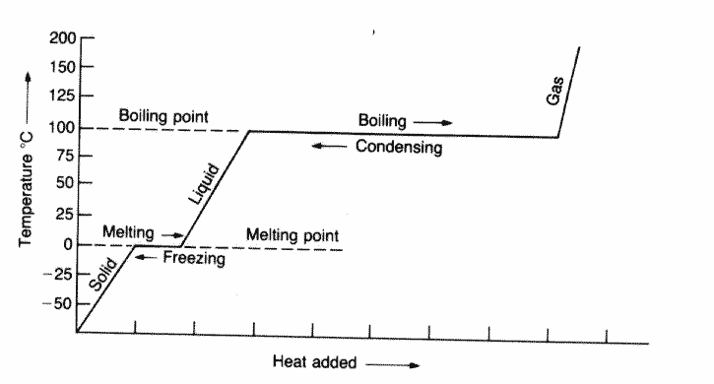

24. What is the condensation point? How is it related to boiling point?

25. What causes condensation on the outside of a glass of cold lemonade?

