Chapter 6 – Electronic Structure of Atoms

6.1 Electromagnetic Radiation – one of the ways energy travels through space
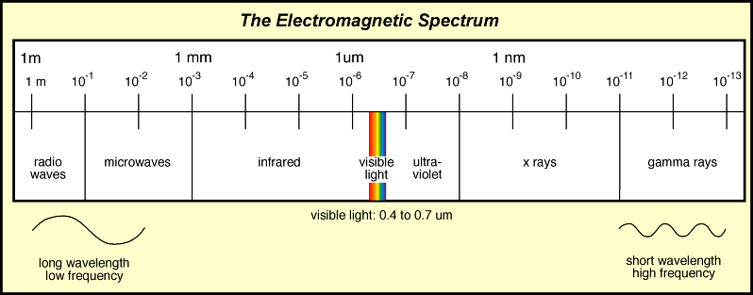

____________________________________ – distance between 2 consecutive troughs or peaks

___________________________ – number of waves (cycles) per second that pass a given point

__________________________________ – all types of EM radiation travel at the speed of light
c = 2.998 x 10⁸ m/s

1900 – Idea prevailed that matter and energy were distinct.
Matter – particles, had mass and their position could be specified
Energy (EM radiation) – Wave, mass-less and delocalized

6.2 Nature of matter

Max Planck (1858-1947) – German physicist – Energy can be gained or lost only in whole number multiples of the quantity ________.

Energy is quantized. Each of these small packets is called a________________. Therefore energy seems to have particulate properties (dual nature of light).

Einstein proposed that EM radiation itself is quantized. EM radiation can be viewed as a stream of “particles” called photons.

The Photoelectric Effect

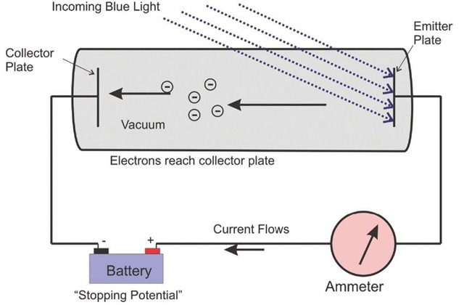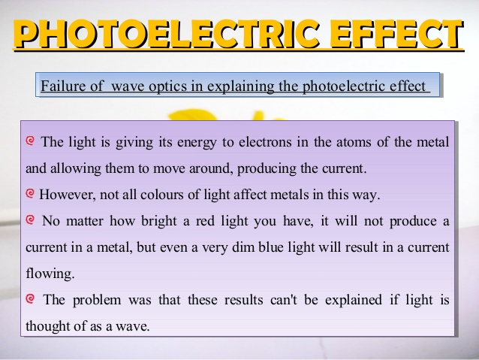

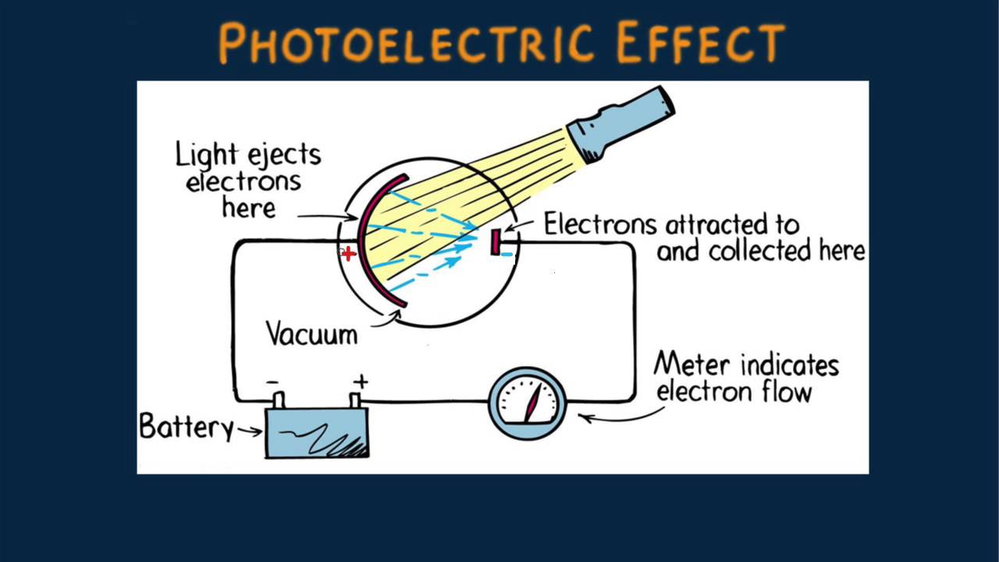

- Visible light that is below a certain minimum threshold frequency will not result in the emission of photoelectrons.

- Increasing the intensity of the light will not help. More light of the same frequency doesn’t change the energy of the light photons. The energy of the light photons is dependent on frequency, E = hν

- The threshold frequency for a given metal is the minimum frequency of electromagnetic radiation for which photoelectron emission occurs.

- Above threshold frequency, the number of electrons emitted does increase with the intensity of the light. Intensity is a measure of the number of photons present. Above threshold frequency, the excess energy is given to the electron as KE.

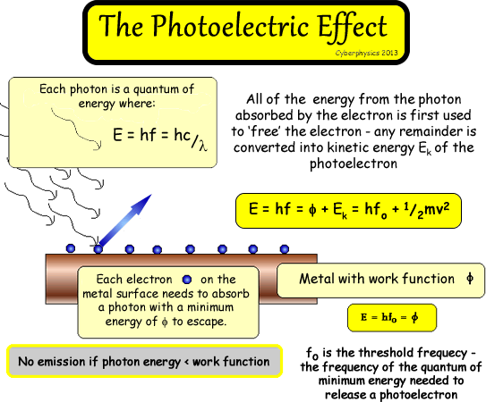

The maximum KE of the photoelectrons depends on the frequency of the incident light.

In Einstein’s time, physicists believed that light existed only as a continuous wave. If this were true, a constant stream of light of any wavelength would eventually remove an electron from a metal. Experiments, however, showed that only certain wavelengths of light were capable of removing electrons. Einstein validated an idea first suggested by Max Planck, that energy can only be transmitted in tiny packets, or quanta. Einstein extended the idea to light, proposing that light is composed of tiny particles called photons. Einstein won the Nobel Prize in 1921 for his research of the photoelectric effect, but he explained the effect in 1905 at the age of 26.

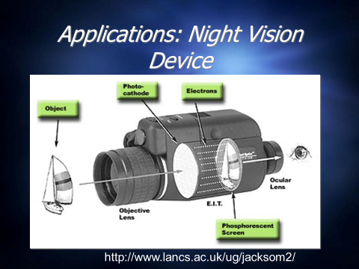
Photons arriving on the photoelectric surface are discreet and hence the numbers fluctuate with time. The smaller the rate of arrival the larger the the fluctuation of any given pixel. This manifests itself as a fluctuating brightness called 'photon noise'.
To combat this, the arriving photons are integrated for longer periods by using a fluorescent screen in which the brightness builds up and decays slowly. There are limits to the integration time. Too long an integration time will cause images to become 'smeared' across the screen.

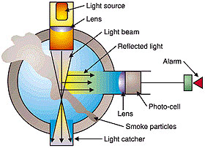
Solar panels use the photoelectric effect to create a stream of electrons.
Smoke detectors. The smoke disrupts the beam of light and causes it to be reflected in a different direction. The reflected light enters a photocell, causes the release of photoelectrons which make a current that triggers an alarm.

In related studies, Einstein developed his theory of relativity: E = mc²
Energy has mass!

Dual nature of matter? Yes!
De Broglie’s equation – allows us to calculate the wavelength of a particle.

READ SECTION 6.4. START ON PAGE 224 AND READ TO THE BOTTOM OF PAGE 225 - When a beam of electrons is directed at a nickel crystal, a diffraction pattern is seen; therefore electrons really do have an associated wavelength.

6.3 Line Spectra and the Bohr Model

When a sample of hydrogen gas is exposed to ____________________________, ___________________, or ________________________, the H₂ molecules absorb some of the energy and some bonds are broken. The resulting atoms are ____________________. Excited atoms release the energy they have absorbed in the form of _______________________________________________________. These wavelengths comprise the emission spectrum of hydrogen.

White light passed thru a prism produces a _____________________________________.

If the visible light from the excited hydrogen atoms is passed through a prism only a few lines of light of discrete wavelengths are produced – this is a _______________________________.

What is the significance of the line spectrum of hydrogen? It indicates that only certain energies are allowed for the electron in the atom. The electron energy levels are quantized. If any energy were allowed, the emission spectrum of hydrogen would be continuous.

A change in energy from a high energy level to a lower energy level would give a wavelength of light that can be calculated using Planck’s equation:

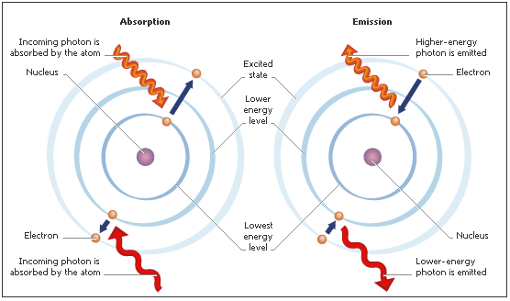

The negative sign means that the electron bound to the nucleus is lower in energy than it would be if the electron were an infinite distance away from the nucleus.

Neils Bohr (1885-1962) – developed a quantum model for the hydrogen atom. He proposed that the electron of hydrogen moves around the nucleus only in certain allowed circular paths.

Bohr’s model results in the following equation:

Ground state – lowest possible energy state

6.4 - 6.6 The Quantum Mechanical Model

By the mid-1920’s, it was apparent that the Bohr model did not work. Historically important because it showed that the quantized energy of atoms could be simply explained.

Werner Heisenberg developed the wave mechanical
Louis de Broglie model (quantum mechanical model)
Erwin Schrodinger

The electron bound to the nucleus seemed similar to a standing wave.

Ex. String attached at both ends
vibrates to produce musical tone;
wave does not travel the length
of the string

Schrodinger decided to treat the electron as a standing wave. He derived something called the wave function (orbital).
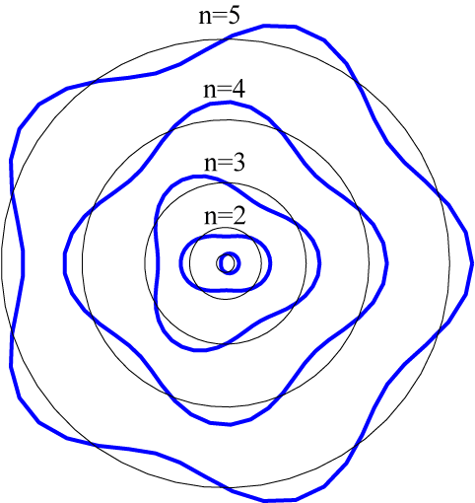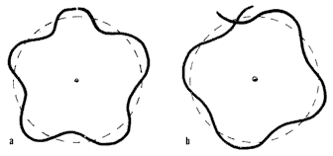
The circumference of a particular circular orbit would have to correspond to a whole number of wavelengths. This idea encouraged scientists to pursue wave theory. It
DID NOT mean electrons travel in circular paths.

The wave function gives us no information about the detailed pathway of the electron.

_____________________________________________– there is a fundamental limitation to just how precisely we can know the position and momentum of a particle at a given time.

The square of the wave function indicates the probability of finding an electron near a particular point in space.
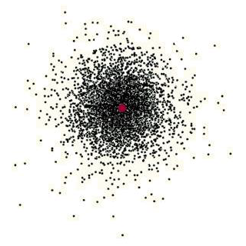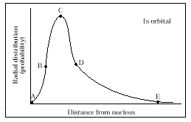

      - electron density = electron probability
- When a chemist uses the term atomic orbital, he is picturing an electron density map.
- The size of the hydrogen 1s orbital is defined as the radius of the sphere that encloses 90% of the total electron probability (90% of the time the electron is inside this sphere).

Quantum Numbers
There are many probability distributions (orbitals) that satisfy Schrodinger’s “square of the wave function” equation. Each orbital can be described by a series of numbers called quantum numbers.

Symbol | Name | Information provided by the number
 |  | Related to the size and energy of the orbital. As n increases the orbital becomes larger and the electrons spend more time farther from the nucleus. As n increase, energy increases. The electrons are less tightly bound to the nucleus and the energy is less negative.
 |  | Related to the shape of the orbital.
 |  | Related to the orientation of the orbital in #-dimensional space, relative to the other orbitals in the atom.
 |  | An electron can spin on one of two opposite directions.

Principal QN
- can be any whole number 1,2,3,4….
- n=1 is closest to the nucleus and lowest in energy

Angular momentum QN
- can have a value of 0-4, each corresponding to a different shape

Integral value | Name | Shape
 |  | Spherical (p.232)
 |  | Figure-8 (p.234)
 |  | Double figure 8 (p.235)
 |  | 8-lobed

Magnetic QN
- called the orbital quantum number
- each sublevel has a different number of orbitals

Sublevel | Shape | Number of orbitals present | Orbital designation
s | Sphere | 1 – there is only one (or an infinite number) of ways to orient a sphere in 3-D space
p | Figure 8 | 3 – these orbitals are represented by three sets of figure eights: one on the x-axis, one on the y-axis and one on the z-axis. The nucleus of the atom is at the point of origin.
d | 4 double-figure 8s and one “odd” shape | 5 – there are five d-orbitals. They are shown on p.297 of your book.
f | Too complex for me to describe!!! | 7 – there are seven f-orbitals. They are shown on page 297 of your book.

Spin QN
- Each orbital can hold a maximum of two electrons!!!!!! These two electrons must spin in opposite directions. (A spinning charge creates a magnetic field and two like magnetic fields cannot occupy the same space.)
- The opposite spins are represented by a +1/2 and -1/2.

Some important things to remember:

_____________________________________________ – In a given atom, no two electrons can have the same set of four quantum numbers (n, l, m_{l}, m_{s}).

______________________________________ - As protons are added to the nucleus to build up the elements, electrons are similarly added to hydrogen-like orbitals. An electron will always occupy the lowest energy orbital available.

There are exceptions to the orbital – filling order. Chromium and copper are two examples. So are molybdenum and silver.

______________________________ – The lowest energy configuration for an atom is the one having the maximum number of unpaired electrons allowed by the Pauli principle in a particular set of degenerate orbitals. In other words, electrons spread apart in the orbitals as long as they have room, then they will double up.

_________________________________– the electrons in the outermost principle quantum level. Important because they are the ones involved in bonding.

____________________________________ – inner electrons

6.7 Polyelectronic Atoms – atoms with more than one electron

Polyelectronic atoms have 3 energy contributions that must be considered:
- the KE of the electrons as they move around the nucleus
- the PE of attraction between the nucleus and the electrons
- the PE of repulsion between the electrons (since the exact path of electrons is not known, this cannot be calculated accurately)

One especially important difference between polyelectronic atoms and the hydrogen atom is that for hydrogen all the orbitals in a given principle quantum level have the same energy (they are degenerate). In polyelectronic atoms, when electrons are placed in a particular quantum level, they “prefer” the orbitals in the order s,p,d,f.

The 2s electron penetrates to the nucleus more than for the 2p orbital. This penetration effect causes a 2s electron to be attracted more strongly to the nucleus than the 2p electron. The 2s orbital is lower in energy than 2p.

